time match
Mon | Tue | Wed | Thur | Fri
1030-1200  Janice  Wil |  |  | Before 1030  Mat  Wil | Before 1030  Mat  Janice  Howard  Wil
 | 1030-11  Mat  Janice  Howard  Wil | 1030-1200  Mat  Janice  Wil |  | 1130-1500  Howard  Wil
1330-1500
Howard
 | 3-430  Mat  Janice | 3-430  Mat  Janice  Wil |  | After 3  Mat
After 7  Janice  Wil | 430-6  Wil |  | After 730  Mat
Weekly meeting: Friday 9-1020 (Library LC06)

Problem (pain point)
Solution
Product
Market size & market potential
Business model
Product positioning
Competitive advantage
Growth
Financials
Milestones
Our team

Appendix
- References
- attributions
- Product timeline
- Current situation
- Persona
- Product description
- (Product inspiration)
- Additional features
- Competition
- Interviews
Problems
- Parents-children
  - Addiction of smart devices
    - Attempt to increase their attention spans
    - Increase the difficulty of them reaching the smart devices
    - Attention apps – YPT / tomato clock
  - Getting them to study
    - Attention apps – YPT / tomato clock
    - Reward schemes - incentive
  - Aggressive child

  - Disobedience

  - Lying

  - Constantly complaining

  - Siblings rivalry
    - Involve parents a platform for parents to give out solutions
    - Do not involve parents à a platform for both siblings to solve e.g. using an app tgt à
  - Tantrums

  - Confidence lacking
    - Practice in front of others / starting from families provide more educational opportunities
  - Improper eating habits
    - An app to track c.f. habit forming apps
    - Suggestions on meals healthier restaurants nearby, more convenient restaurants available, can integrate howard’s initial idea
  - Neglective parents
    - Children misbehave / spoiled by their grandparents/domestic workers etc physical and mental growth
      - Physical: obesity
      - Mental: lack of love how to build the connection between parents and children
- Health
  - Diabetes
    - Habit tracking app (with some distinct functions)
  - Cancers
    - No way
    - A portable / affordable device for families to track parameters daily
  - Influenza

  - Respiratory disease
    - Due to air pollution
    - Masks or improved masks à how to make a mask more convenient / less uncomfortable / portable device tot
  - Injury
  - Accident
- Pets
  - Veterinary care
    - Too expensive, how can we reduce the cost of going to vet, or try to solve problems when an owner find their pets being unwell (primary target: cats and dogs)
- Elderly
  - Health conditions
    - Hearing loss
      - Earbuds more comfy,
    - Cataracts

    - Back and neck pain
      - Massage machines, can scan their body to adjust the positions and the forces accordingly, can be portable or easily reached
    - Chronic diseases
      - An app for doctors or families to monitor the meals of elderlies
      - Should be very user-friendly, also look at the safety concerns
- White collar worker
  - Long working hours
    - Eyes: some wearable devices to sooth their pains / filter out harmful lights / reduce the __ stresses for glasses, it should be light and ergonomically correct
    - Neck and back pains: ergonomically correct chairs / massage device c.f. elderly
  - Isolation and loneliness
    - Social apps more reliable than existing apps
    - Establish a community: make up an organisation with a lot of activities (they may not have the time to join)
  - Health risk
    - Devices to track parameters
  - Work-life balance

  - Obesity
    - How to encourage exercise, or passively making them eat better (try to minimise the effort users have to take to solve this problem) if they suffer from obesity, they usually have a low motivation to change the current situation / no time to do so

- In general
  - Habit forming
  - Health
- Price comparison 格價
  - Maybe need more research on competitors
- VR (China government target)
  - Not focusing on the high tech part (As feasibility is low)
  - Would it be possible to cooperate with VR company? (like tourist experience)
- Enterprise credit (increasing industry, Credit Suisse, Silicon Valley Bank)
  - ? How to help build or repair enterprise credit? (need brainstorming / knowledge)
- remote workers and digital nomads:
  - Description: With the popularity of remote working technology, being remote workers and digital nomads become popular trends. They are facing the following problem:
    - Isolation from community
    - Relatively lower productivity (own device, narrow bandwidth, etc.)
    - Require collaboration for projects (sth like part time or gig workers) (as digital nomads keep travelling, they may not focus on the job only from one company)
    - Work-life balance

  - Existing idea: coworking spaces
    - provide an environment that fosters collaboration, networking, and idea sharing among individuals from diverse backgrounds and industries
    - Flexible membership option
    - Sharing device and network → cost allocation
    - Community-Driven, there are some researches reporting that community linking is really fancy to digital nomads

  - We may focus on building a strong sense of community within your coworking spaces, or anything else that can make us stand out (unique / specialized) (combining existing ideas)
- New tutor planform business model
  - Pricing
- CNY
  - Weak bonding with relatives
  - Relatives Not that closed
  - Cost of red package

29.2.2024 Review Session 1
Problem: cannot use authorisation with phone number
CM: Cannot answer a phone call with the SIM card / chip —> tourist sim card usually do not have an active
Make physical products which connect to an app (app should not be the main product)

CM: Identify clearly who are the target segment

Combined solution of edu and translate
CM: Define new competitors
Change market segment to who really want to learn a foreign language

CM: Ppl/ companies will translate for foreigners
It is not difficult for making English version, market size may be small, need more updated evidence

Year of founding of translate on screen, why no sale in China?

CM: not many upsides, lots of downsides

Change or add on?
CM: need unique advantages

Translation market is mature
CM: so many giants, technology too fast. If want to be bought out (related to the own cost for the giant to do the things), need deep tech
Amazon, robotic cat, some billions
CM: How to get in? Competitor so strong, (obtainable) market size would not be huge

CM: Advertisements only apply to apps with large traffic

CM: two important: define customer precisely and understand their needs, understand the target segment, how our product can attract them, how big is the market

look back ideas
outfit recommendations
CM: many competitors, easy go in. Don’t go into crowded area (Red Sea), unless is for own application

Pre-cooked food
CM: look at other ideas, what is the unique point, Analyse the top companies: price, value, convenience, taste, special features, do competitor analysis
hot pot 海底撈, shabushabu tailor; McDonald, entertain local customer, localization (put into customers’ shoes)
Why successful, what have been done?
Hong Kong market is complicated

Bus app
CM: elderly probably know the ways quite well, HK is small, elderly not go many places —> not huge demand, few ppl need that.
Need analysis of target segment
City mapper

Assignment area, only GBA?
CM: difficult to understand the market, no idea on the market, just imagination, culture, need. Even Beijing, different from HK demand, hypothesis is cheap, only verified hypothesis is valuable

CM: Need relax and brainstorming, own experience
common to kill the first idea
Organise meeting

Translation market is big actually
CM: Translation of legal doc is big thing, contract, highly special

CM: being open minded,
uber, before it, ppl think taxi is the only way, difficulty: routing map

End of Review Session 1

Alternative:
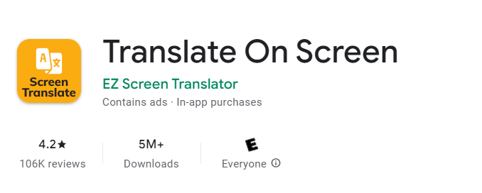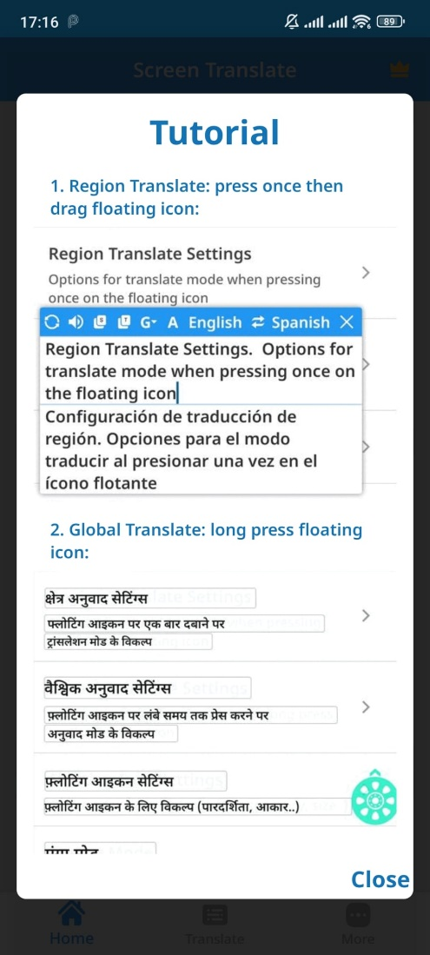
EZ Screen Translator is also a text translator, photo translator, camera translator, voice translator. + Bubble Translation floating on the screen
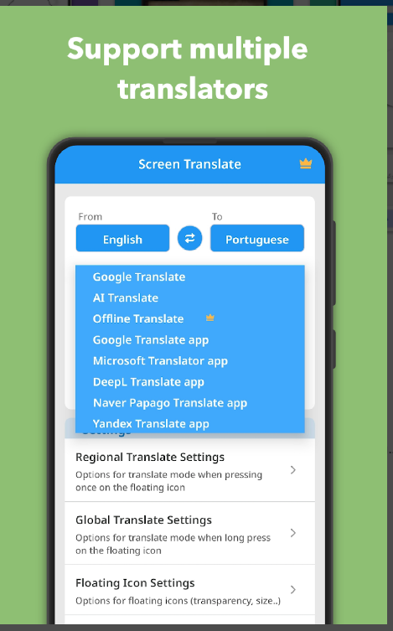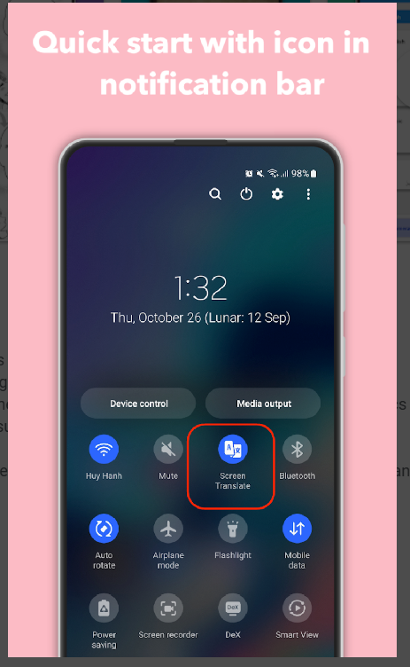
https://play.google.com/store/apps/details?id=com.recognize_text.translate.screen&hl=en&gl=US
https://apps.apple.com/us/app/ez-screen-translator/id6463492037
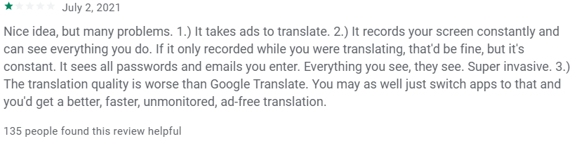
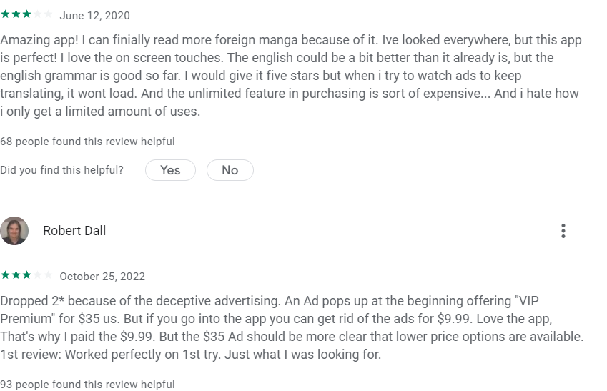
Other apps for reference: (can be inspired by some of their function)
https://play.google.com/store/apps/details?id=com.gaminik.i18n
https://play.google.com/store/apps/details?id=com.niven.game
https://play.google.com/store/apps/details?id=com.screen.translate.google
https://play.google.com/store/apps/details?id=com.niven.translator
https://play.google.com/store/apps/details?id=com.spaceship.screen.textcopy
I am just thinking of anything that we can do to make our app stand out, and I have an idea.
The reason behind people using a translation app is because they don't know Chinese, and maybe some of them are willing to learn Chinese, then why don't we combine these two functions. Perhaps re-segmenting is the way to go when we are facing such similar competition 🤔🤔
So the idea is that
1. We ask if the user is interested in learning Chinese
2. Analyze the text translated and extract the words that are worth learning (maybe at first it's the most common 1000 words, as the user learns more Chinese, the scope should of words that's worth learning should be enlarged)
3. In another page for learning Chinese, it automatically screenshot the page that is translated then highlight those worth learning words. When the user click it, then it will provide the meaning+ pronunciation+ sample sentence( which is the translated version of the sentence that the word come from)
There are a few advantages:
1. The scope of the user can be larger, we don't need to limit ourselves to the china market if we incorporate the learning function. For example, if people enjoy reading Japanese comics or enjoy playing Japanese games, they can learn Japanese during when our app helps them to translate
2. Larger incentive for them to use our app rather than our competitor
[09:09, 28/02/2024] Matthew: ut I think the user will choose to opt in this function or not
[09:09, 28/02/2024] Matthew: First we will ask them, if they don't want , we just keep it simple to a translation app
Cmt: if they don’t want, they will simply use the other translation apps

1.3.2024
Problem ideas:
- lack community: trustworthiness / relation /
- lack confidence
- dressing
- cant wake up
- irregular eating
- socialising
- not close with relatives
- stress and tension
- new year living cost
- phone related: accessories

younger elderly (just retired 60-75)
- Mental health
  - Loneliness – small social circle
  - Negligence
  - Lack of goal
  - Physical ability – movement, disability
- Retirement transition
  - Nothing to do
  - No focus

Pokemon like thing
- For people who want to freestyle
- Matching with ppl nearby

Solution
- Hobbies forming ***

- Volunteer – platform ** Education – they can be teaching / learning ***
  - Connect with other elderly / children by teaching their interests
- VR games ***

Jobs inspiration:

https://www.greatseniorliving.com/articles/jobs-for-older-people
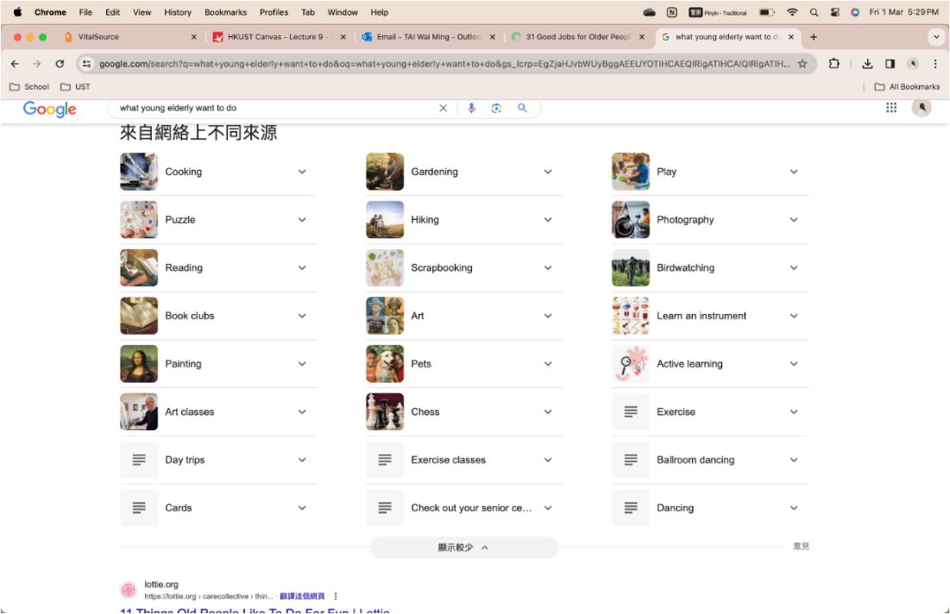
competitors:
- https://hkare.org/job-matching-services/
- https://www.hkfws.org.hk/how-we-help/elderly-and-community-support-services/enhanced-home-and-cummunity-care?gad_source=1&gclid=CjwKCAiAloavBhBOEiwAbtAJO-qadh5awJGZUw4M4GClQ3Bg-04RxT9RGgJR7jtV227DIVmpwkdAQhoCL_gQAvD_BwE
- https://www.aka.org.hk/aka-programs-for-elderly/?gad_source=1&gclid=CjwKCAiAloavBhBOEiwAbtAJO7Sl5MFOIJ0REhQqNJGJGUeS8i_vIFrLKu0kE0FzOx6m88ZntwDGbBoCjnAQAvD_BwE


- Teenage dreams
- Community app
- Elderly dating app
- Work again – job finding for elderly
- Robot pet
- Robot helper
- VR games ***
- Virtual kids
- Suggest what they can do on an app (according to price levels etc)
- Part time matching for elderly: e.g. buy groceries together, help auntie in the park to buy a cake / help neighbour to walk the dog *

